Networking

Making VLAN

In a switch
First create the vlans, all vlans have to be make in all the switches

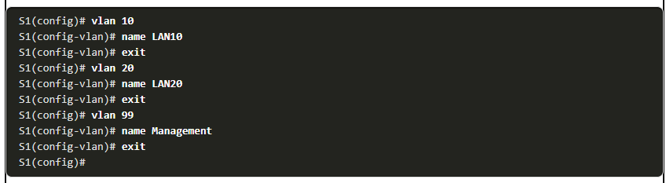
Then you need to configure the native Vlan and if necessary the default gateway for the switch

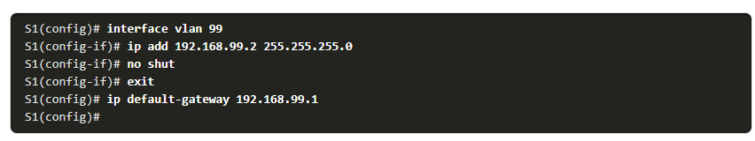

Then you need to assign the interfaces of the switch where they have the host connected to the right Vlan and configure It in access mode
if there is more than 1 interface use the range command

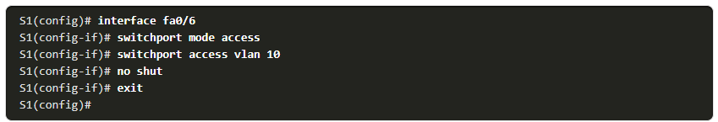

You need to configure the connection between the switches and router like in trunk mode and setting which vlan traffic is allow on each trunk
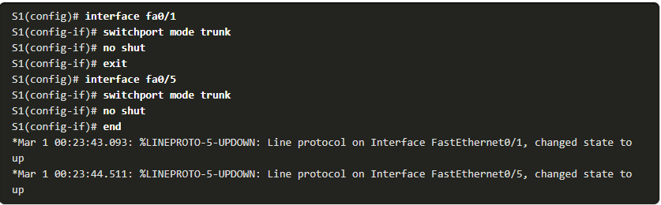
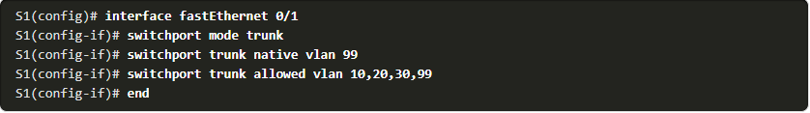

assign a default gateway for each regular switch, so they can be manage remotely

In the Router
we need to identify each Vlan in the interface that’s coming from with the interface.vlan, and enable the encapsulation also the main interface if you want we can give a description and activate no shutdown(IN A LV3 SWITCH IS NOT NECESSARY TO PUT THE .VLAN OR ENCAPSULATION, WE JUST ACTIVATE THE VLANS IN THE SWITCH AND CONFIG THE IP AND MASK AND ACTIVATE IP ROUTING IN THE SWITCH)
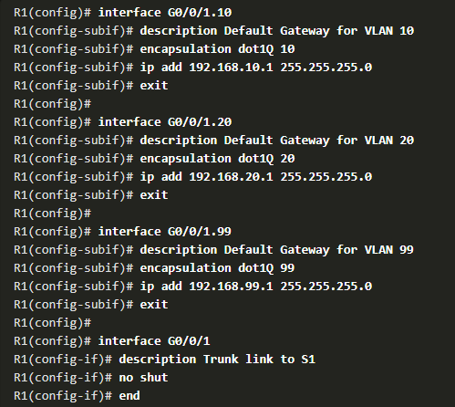

Setting the ip(default gateway) for each Vlan
in the router or lv3 switch
(config)#interface vlan __
(config-if)# ip address ____ and the mac ___
add description if necessary

With lv 3 switch and router
Set the interface that connects the lv3 switch and the router as a no switchport (it will become router port) and out a ip address and mask so it will serve as a default gateway for the vlans
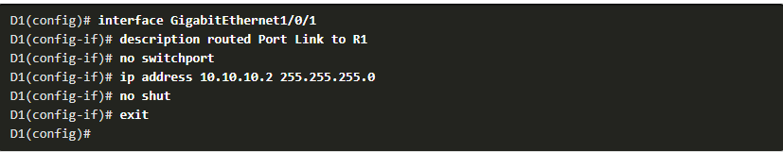
Then remember to activate the ip routing option on the lv3 switch

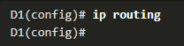
Now configure the routing protocol OSPF for announcing each Vlan on the switch, the network ip has to be the ones from each pc and the network that the switch and router share.
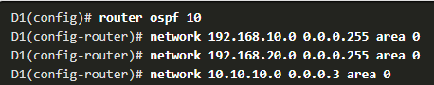

Router/switch commands to check vlans
- show ip route
- show ip interface brief – router trouble
- show interfaces – router trouble
- show interfaces trunk
- show vlan brief – missing vlans
- show interfaces switchport -missing vlans
- show interfaces trunk – trunk port problems
- show running-config – trunk port problems

Spanning tree
When is portfast it goes from locked to online in a very few seconds avoiding other middle states
nfvis(config-if)# spanning-tree portfast enable or default ( set default) global or single interface (global gives issues sometimes)
nfvis(config-if)# commit
nfvis(config-if)# end

Change spanning-tree port cost
nfvis(config)# interface range / or single vlan 10,30….
nfvis(config-if)# spanning-tree vlan 1,20,10 cost(change port cost) / port priority (same price choose one)

Commands
nfvis(config)# spanning-tree vlan __ priority 12288 - do this in every switch
nfvis(config)# commit
nfvis(config)# end
nfvis(config)# spanning-tree enable
nfvis(config-)# commit
nfvis(config-)# end
nfvis(config)# interface gigabitEthernet 1/1
nfvis(config)# spanning-tree vlan __ root – defines if its primary or secondary bridge port
nfvis(config)#spanning-tree vlan _ , _ , _ , _ , root primary / secondary or priority → this sets the switch as the root bridge
making switch root bridge for vlans
spanning-tree vlan _ , _ , _ , _ , root primary / secondary or priority → this sets the switch as the root bridge

EtherChannel

Protocols

PAgP- states (cisco only)
- on
- desirable
- automatic

LACP states
- On
- Active
- Passive

Requirements
- All interfaces must allow etherchannel
- Speed and duplex should be the same
- Vlan consistency must be the same in the interfaces
- The allow range for trunking should be the same on the etherchannel

Config
Choose the range interfaces and assign them a group number and a protocol mode, then config the interface as trunk and define which vlans are allow to run trough
Also config the native
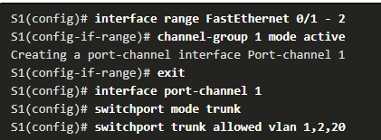

Commands to check etherchannel
- show interfaces port-channel 1
- show etherchannel summary
- show etherchannel port-channel
- show interfaces f0/1 etherchannel

DHCPV4

Steps
CLIENT SEND CLIENT BROADCAST DHCPREQUEST 🡪SERVER ANSWERS WITH DHCPOFFER SAYING IM A SERVER HERE IS YOUR ADDRESS
CLIENT ACCEPTS ADDRESS WITH DHCPREQUEST WITH A BROADCAST 🡪SERVER SENDS DHCPACK LIKE A VOUCHER IN UNICAST

CONFIGURE IN ROUTER ONLY OR LV3 SWITCH
First we need to add the excluded address for each vlan or lan that we don’t want dhcp to give automatically
Router(config)# ip dhcp excluded-address low-address [high-address]
Then we need to assign a pool name for all the ip pool for each vlan or lan
Router(config)# ip dhcp pool pool-name
Router(dhcp-config)#

After both are done and we are in the dhcp-config we can start adding the network id for each lan or vlan we are using and the mask, then the default router ip of the vlan or lan and the dns server ip, also the domain name (Optional)
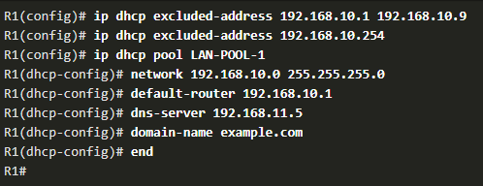
To enable or disable dhcp we can use this command
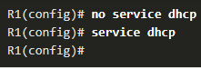

To configure router or switch as dhcp client
Instead of adding ip address write dhcp and it will automatically ask for an ip
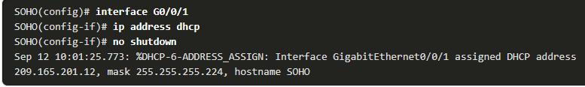

Commands to check DHCP
show ip dhcp binding – it show all ipv4 assign by the server
show ip dhcp server statistics
show running-config | section dhcp

in pc
ipconfig /renew /release

SSH
switch
config# ip domain name choose name
config#user name admin secret cisco
config# crypto key generate rsa
bits 1024

config#line vty 0 4
config-line# transport input ssh
config-line# login

